Use of Facilities by Third Parties for Free Speech

Summary

The following constitutes the State University of New York College at Cortland’s “time, place and manner” policy on the use of SUNY Cortland-owned (the university) facilities by third parties (non-university or sponsored by recognized student organizations) for free speech purposes as by the University Council pursuant to a delegation of authority by the SUNY Board of Trustees. See SUNY Policy #5603 “Use of Facilities by Non-Commercial Organizations.”

Reasons for this Policy

As an institution of higher education, the university respects and fully supports the rights granted to individuals under the First Amendment to the United States Constitution regarding free speech. The university has adopted free speech policies with respect to its students, faculty, and staff, but not for third parties, who are not sponsored by the university or a recognized student organization but want to use the campus for free speech purposes.

As a public entity, partially funded by New York state tax dollars, the university will provide a designated public forum to third parties outside of the campus community for their exercise of free speech rights. To comply with existing law, the university recognizes that it will be dedicating its scarce resources to the third parties, including staff time for the management of the designated public forum, the cost associated/loss of revenue with the use of space itself, and possibly utilizing university police and other administrative offices’ staff, to provide for the public safety of participants.

In adopting this policy, the university weighed its competing obligations and responsibilities: to meet its legal obligations as a public entity to provide a designated public forum for free speech by third parties; to meet its audit and control obligations in managing New York state property under its jurisdiction; and to meet its obligations for the orderly and safe operation of its campus, while responsibly managing and allocating its scarce resources in pursuit of its education mission for its students.

Policy Application

This policy shall apply to all third parties, who are not sponsored by the university and/or a student group, who want to use the university’s designated public forum for free speech purposes. This policy does not apply to students, speakers officially sponsored by recognized student groups, faculty or staff as other reservation and use policies apply to those campus community members.

Definitions

Black-out days: The university has blacked-out certain days on its calendar wherein the use of the campus and its facilities, including outdoor spaces are reserved exclusively for campus-related activities that are at the very core of its primary educational mission. During these blackout periods, no third party shall be allowed to use the designated public forum for free speech purposes. The university defines the blackout periods to include the following:
- During opening weekend for the commencement of fall and spring semester;
- During reading periods and examination periods as set forth on the then-current academic calendar.
- During graduation-related activities and events, including undergraduate and graduate commencements;
- During major fall or spring campus-wide celebrations, such as concerts, Homecoming, and Spring Fling; and Open Houses.
- During such times that the university is hosting major campus events which require significant staff resources.
- During the conservation shut down of educational buildings and administrative offices as defined on its calendar when the temperature of the offices shall be below 60 degrees Fahrenheit — typically between the end of the examination period when students leave campus for the winter holiday break and a few business days after the first of the year. This timeframe is included in the black-out period because the offices are typically closed for the receipt of applications and the campus is virtually vacant to conserve energy and to save money to meet state budget reductions.

Designated Public Forum: The university identifies the following area as its designated public forum: the outside area of Corey Union beginning on the south side of the southern tree, extending 12 feet south on the sidewalk, encompassing a rectangle area that is 10 feet in width.

The university designates this outdoor space for its designated public forum as this space is the most highly pedestrian trafficked area on the university main campus by students, faculty, staff and visitors. Corey Union houses the food court and several other student services offices, as well as the Function Room and frequently used meeting rooms for the university campus community. The use of this space is also not likely to interfere with classroom instruction or residence halls.

Additionally, the university has identified an outdoor space by the university’s athletic fields. This space is due east of the 281 Parking Lot on the grass area. This area is approximately 20’ by 30’, and will be roped off if appropriate.

An auxiliary area could also be available should the university deem it necessary. This area would be due east of the Lankler and Stratton intersection. This area may also be roped off, approximately 20’ by 30’.

Third Party: A person(s) who wishes to use the designated public forum for free speech purposes and the person(s) is not a student, faculty or staff member at the university, and the person(s) is not officially sponsored by either the university and/or a recognized student group to speak at the university.

Policy

A. The university is providing a designated public forum for use by third parties for their free speech purposes.

B. Reservation and Record Keeping of the Use of Space:

1. Third parties who seek to use the designated public forum must:
- Complete a designated public forum application; and
- File the application with the director of Campus Event Management four business days before the date the applicant wishes to use the designated public forum. Applications received after 3 p.m. on a given business day shall be considered as having been received on the morning of the next business day. The applicant assumes responsibility for proper and timely delivery of an application to the director of Campus Event Management. The office is open 8:30 a.m.-4 p.m., Monday through Friday, for deliveries, except for holidays and certain university black-out days as noted within this document.

2. The university shall review the application and respond to the applicant no later than the close of business on the second business day following the receipt of the application.
- If the application is completed fully and signed by the applicant and the date and time are available for use, the university shall inform the applicant of its approval to use the designated forum on the date and time requested.
- If the application is not complete and/or it is not signed, the university shall return the application to the applicant for completion. The three business days’ time period will begin running again once the completed and signed application is received by the director of Campus Event Management.
- If the space is already reserved to its capacity for the date and time requested, or if the date and time requested is during a blackout period as defined below, the university shall inform the applicant and offer the applicant the next available date and time for the use of the space.

C. The university shall not:
- Inquire as the nature or content of the free speech;
- Charge the applicant an application fee to reserve the designated public forum;
- Charge the applicant/third party for the use of the space;
- Impose insurance requirements on the applicant/third party; or
- Charge the applicant for any additional costs to the university that the university may incur due to the use of the space by the applicant/third party, such as security.

D. The applicant/third party shall:
- Be responsible for any costs for parking on the campus as all students, faculty, staff and visitors are charged for parking.
- Be responsible for picking up from the designated public forum any brochures, pamphlets, leaflets or other handouts or goods that the third party speaker brought with him/her to disseminate during their speech, and properly disposing of the same in public garbage receptacles or taking them with him/her. The university has a regulation against littering on the campus that applies to all students, faculty, staff and visitors. Failure to comply with this provision may result in future denial of use of the designated public forum; and
- No use of any noise amplification equipment for speech without prior permission. Determination of permission will be based on the potential disruption of classes or other legitimate business uses.

E. The university reserves the right to terminate any use of the designated public forum in the event either the speaker or a member(s) of any audience engages in conduct that violates the SUNY Rules for the Maintenance of Public Order, adopted in accordance with Education Law Section 6430 and 8 NYCRR 535, in order to secure the orderly and operation of the campus for the safety of the entire campus community.

All applications must be reviewed and approved by the director of Campus Event Management or designee with input from UPD, Emergency Management, Facilities Operations and Services, and any other affected department. Applications must be filled out, printed and signed by the applicant. Completed applications can be mailed or dropped off to:

Todd Malone
SUNY Cortland Director of Campus Event Management
Mailing Address: P.O. Box 2000
Physical Address: Carl A. “Chugger” Davis Building, Room 101
Cortland, NY 13045
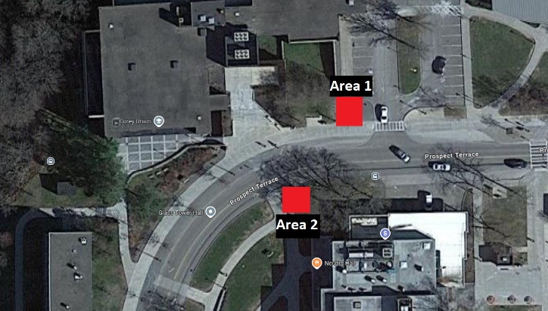

Outside Corey Union Designated Public Forum Location(s)
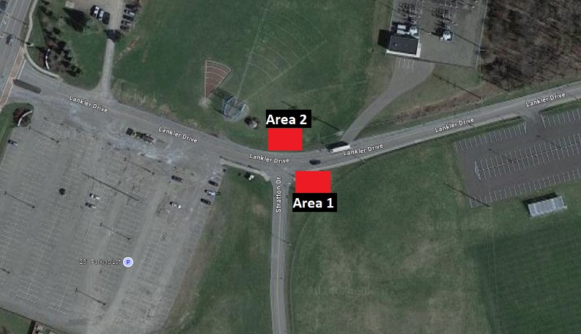

Stratton/Lankler Drive Designated Public Forum Location(s)

Application for Use of the Designated Public Forum
State University of New York, Cortland
1. Date of Application: Click or tap to enter a date. | 2. Formal Name of Organization or Individual (Applicant): Click or tap here to enter text.
3. Applicant Mailing Address: Click or tap here to enter text. |  |  | 4. Name of Applicant Contact: Click or tap here to enter text.
5. Applicant Telephone Number: Click or tap here to enter text. |  | 6. Applicant Email Address: Click or tap here to enter text.
7. Nature of Activity (Describe Activity – distribute literature, display posters, etc.): Click or tap here to enter text.
8. Requested Date(s) for Event: | 9. Start Time of Event: Click or tap here to enter text. |  | 10. End Time of Event: Click or tap here to enter text.
11. Name of Responsible Individual at Event: (if different from above): Click or tap here to enter text. | 12. Responsible Individual Telephone Number: Choose an item. |  | 13. Responsible Individual Email Address: Click or tap here to enter text.
14. Location of Event:
15. Describe display, literature, equipment, furnishings, materials to be used (for example, tables, chairs, displays boards, pamphlets or brochures, etc.): Click or tap here to enter text.
☐I, the applicant, have read the foregoing policy and agree to comply with the terms of use of the designated public forum as set forth in the policy.

☐I, the applicant, acknowledge that I am applying to use the designated public forum for free speech purposes, that I will use the designated public forum space for free speech purposes, and that I will not use the forum for any other commercial or noncommercial uses that require a revocable permit in accordance with the SUNY Policy of Noncommercial Use of College Facilities by Third Parties and/or commercial purposes that are not allowed on/in SUNY Cortland facilities.
Date: Click or tap to enter a date. | Print Name of Applicant: Click or tap here to enter text.
Applicant Signature:

FOR SUNY CORTLAND USE ONLY:
Date Application Received: |  | Time Application Received:
Manner Application was Received: | Date SUNY Cortland Reviewed: |  |  | Approved?
If returned, reason: |  |  | Date:
If approved, SUNY Cortland Signature(s): |  |  | Date:
Follow-Up:

